**9) How to host a website using Kubernets Engine?**

Step 1 : Find a github repository for hosting the website : https://github.com/learning-zone/website-templates

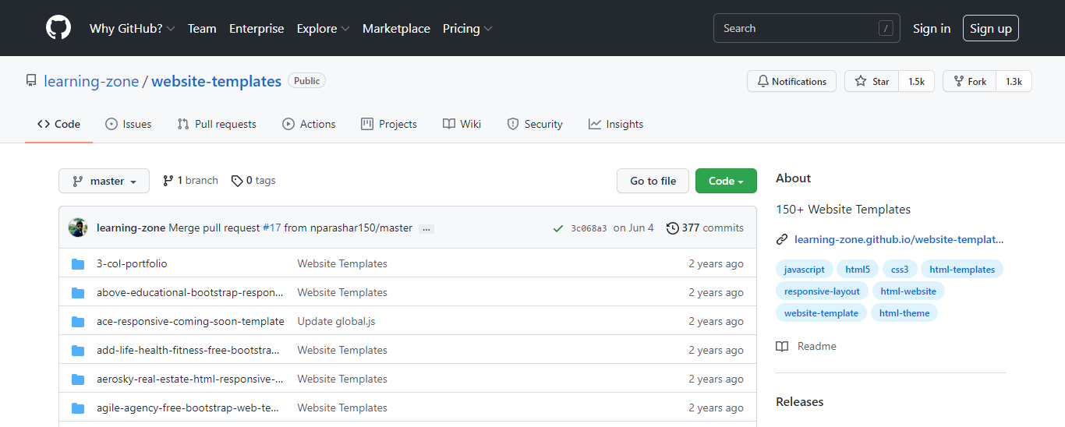

Step 2 : Open the cloud shell and make a directory ‘temp’.

Step 3 : Inside that directory clone the github site using git clone command and then go to the path of github repository which contains the required files.

Step 4 : Create a container using docker run command and view the running containers by using docker ps : docker run -d -p 8080:80 nginx:latest

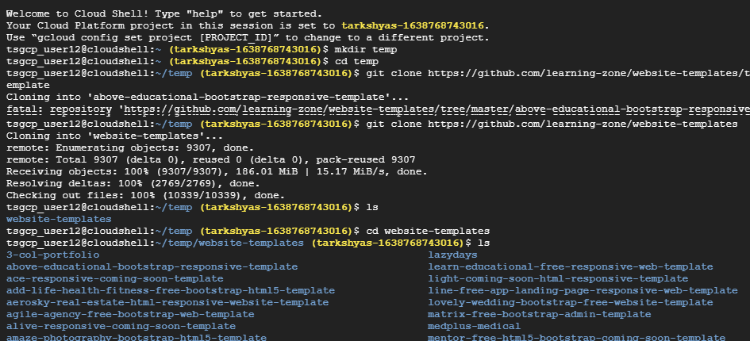

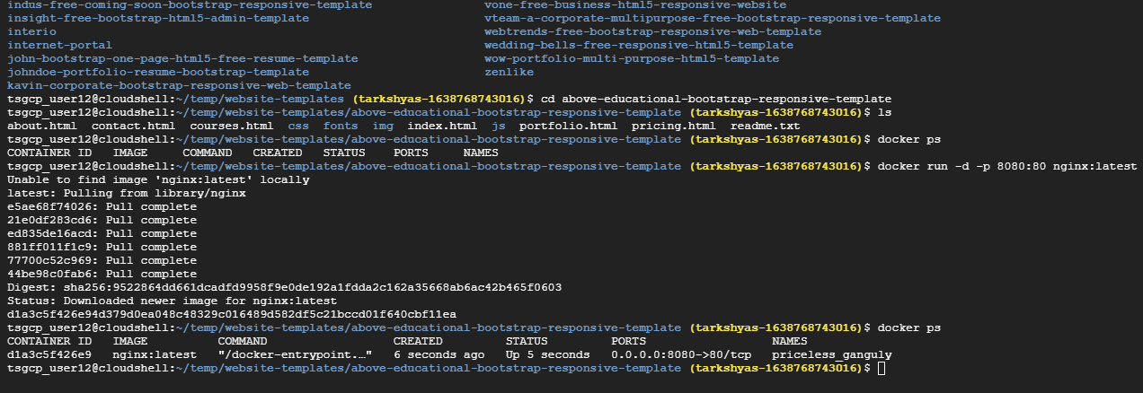

Step 5 : Copy all the files insides github repository to the container by using docker cp command : docker cp about.html d1a3c5f426e9:/usr/share/nginx/html/

Step 6 : Then commit docker inorder to allow users to take the running container and save its current state as an image : docker commit d1a3c5f426e9 testsite:version1

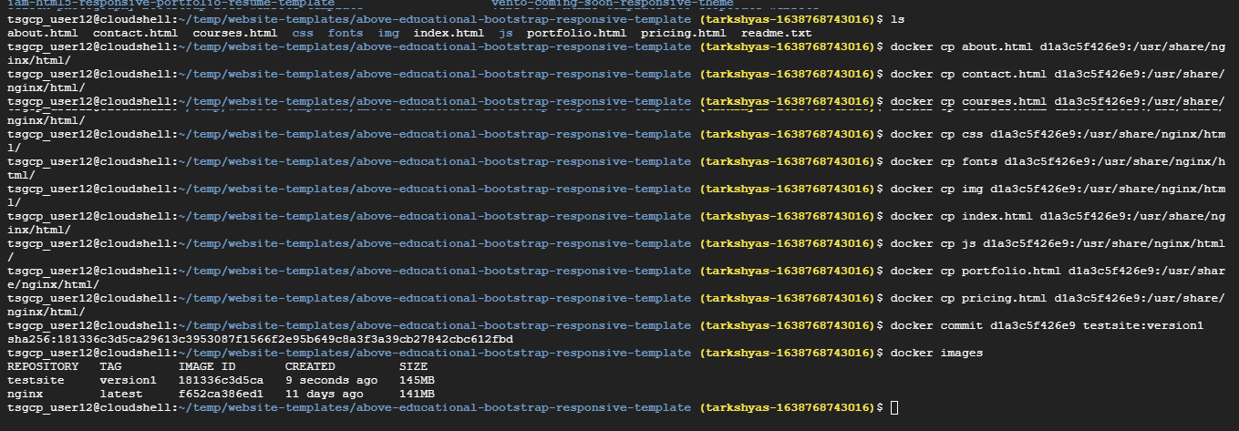

Step 7 : Share those images to the Docker Hub registry using docker push :

docker tag testsite:version1 us.gcr.io/tarkshyas-1638768743016/testsite:version1

docker push us.gcr.io/tarkshyas-1638768743016/testsite:version1

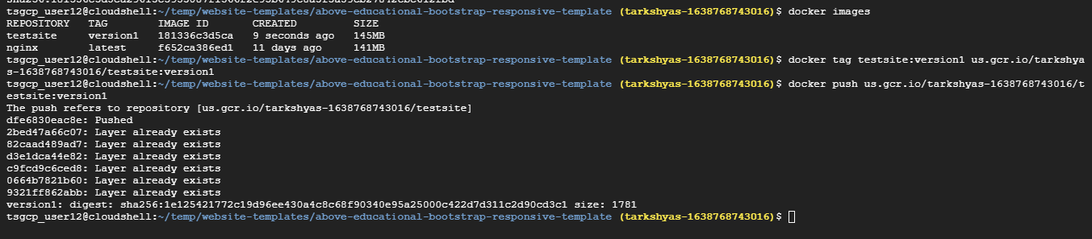

Step 8 : Go to th container registry and view the image created

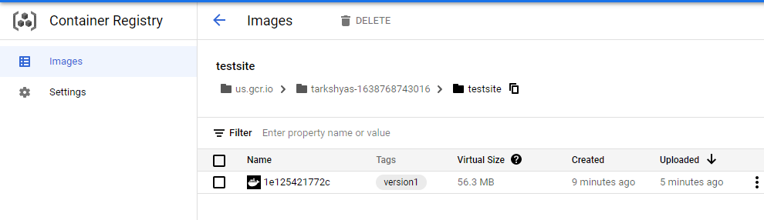

Step 9 : Open Workloads in Kubernetes Engine and deploy the application

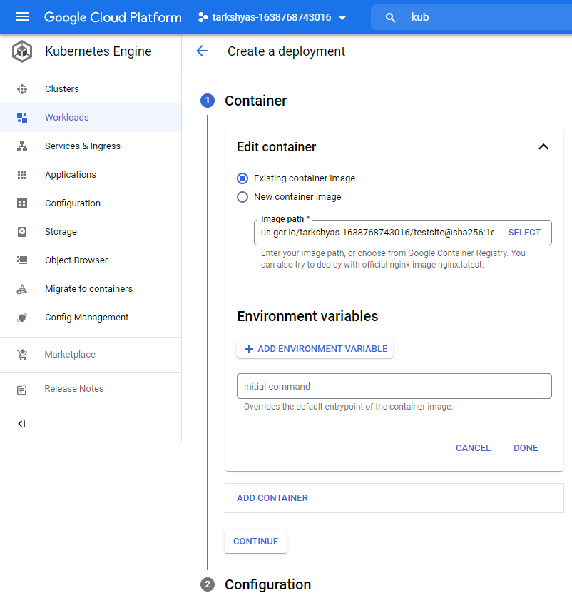

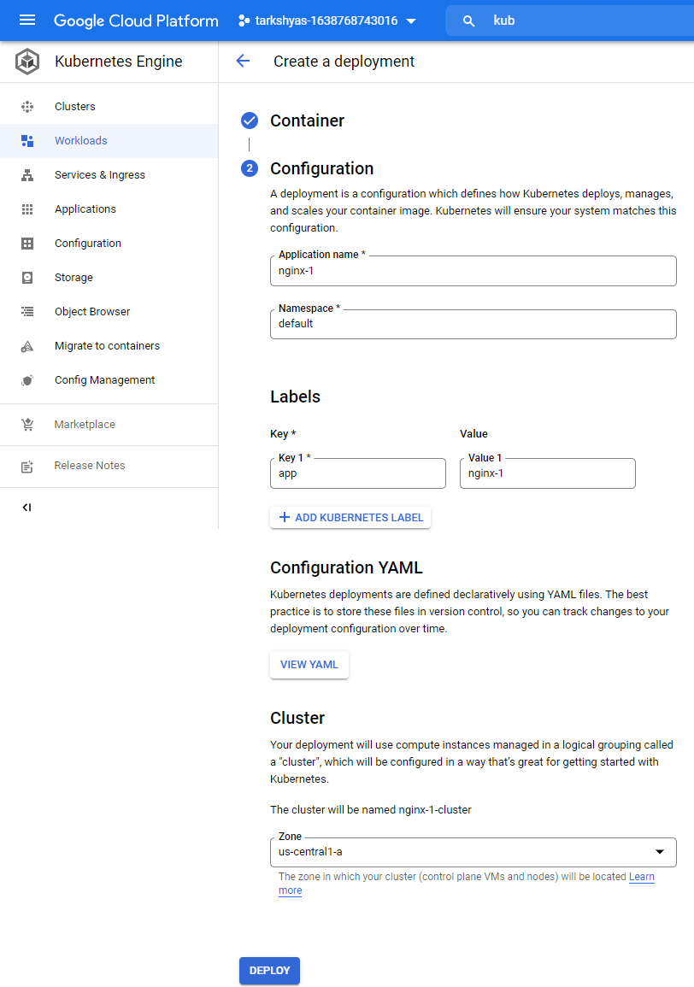

Step 10 : After deploying

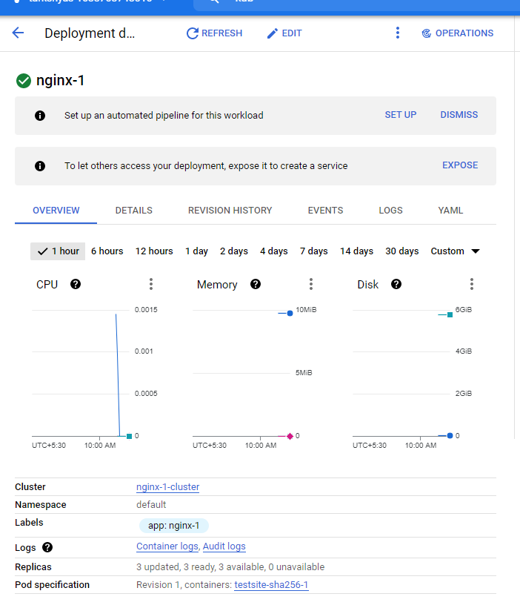

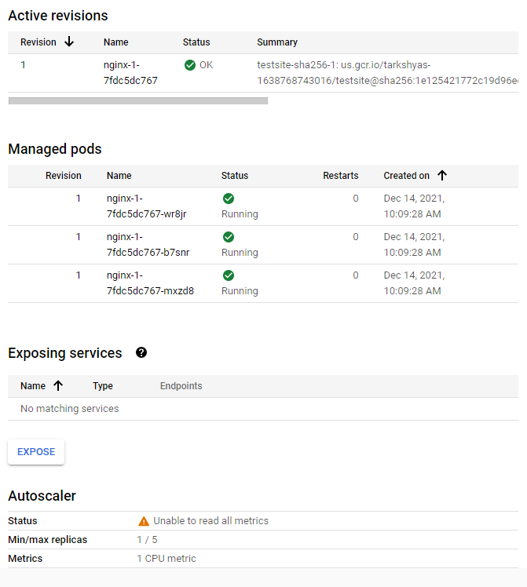

Step 11 : Expose the deployed application

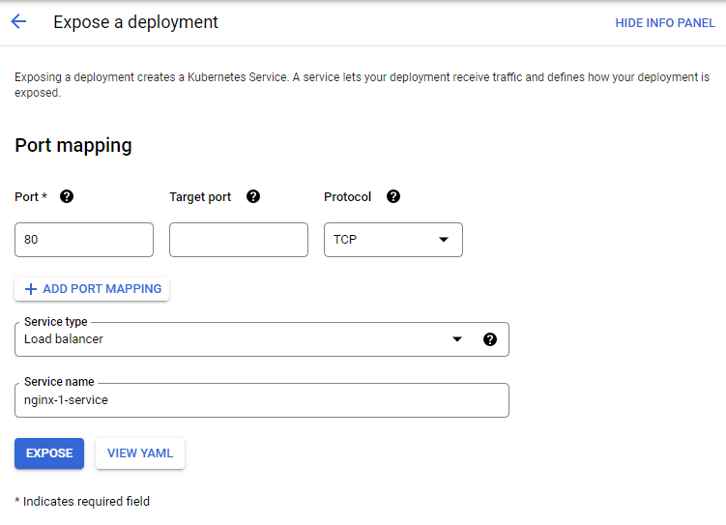

Step 12 : Now by clicking on external endpoints , it will redirects to the required site.

